Homework report

Course: Computer Vision 2020

Francesco Pham (1234004)

# Lab 5 - Keypoints, Descriptors and Matching

Inside panoramic_image.h you will find the PanoramicImage class which contains some static methods for the creation of the panoramic image, the implementation is inside panoramic_image.cpp. The file panoramic_utils.h contains a static method provided by the prof for the projection of the images in a cylindrical surface.

During program execution you will be prompted to type in the input images path and the field of view angle.

The first two steps of the homework were immediate, loading the images as done in the previous homework and projected the images on a cylindrical surface using the method provided by the prof.

Inside PanoramicImage::detectAndMatchKeypoints I extracted the features and the descriptors using SIFT feature detector and matched the features between the pairs of consecutive images using BFMatcher .

The method PanoramicImage::computeTranslation is then used for computing the relative translation vector between a pair of images based on the detected matches. findHomography is used to discard outliers, then an average of the translations between remaining matches is computed.

Finally PanoramicImage::joinImages is then used to stitch the images together using the computed translations to produce the final result image, the output image size is computed based on the given translations.

At the top of panoramic_image.cpp there are two constants DISTANCE_RATIO_THRESHOLD and RANSAC_REPROJ_THRESHOLD used to regulate the discarding of the outliers based on the distance between matches and the Ransac threshold, after trying different settings I finally kept the values 5.0 and 3.0.

## Final result

After testing it on the images given by the prof, I can see that the pictures are stitched together quite well, with only some change in brightness between image boundaries.

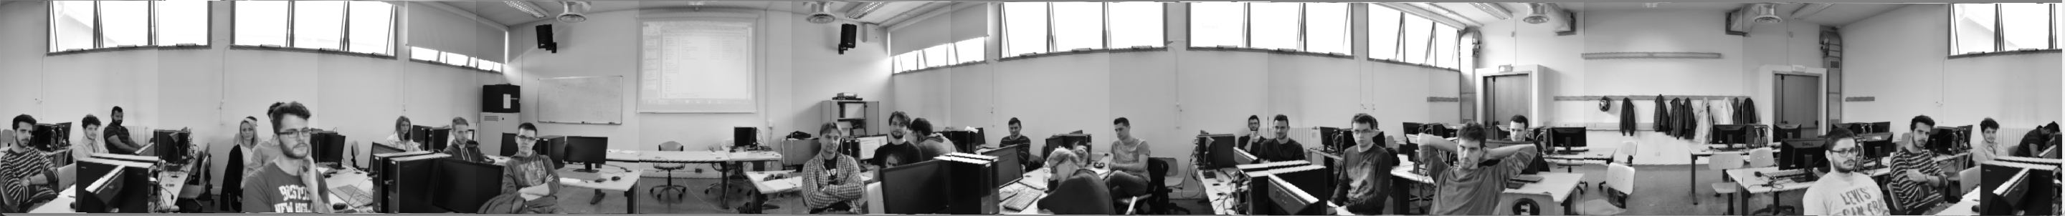

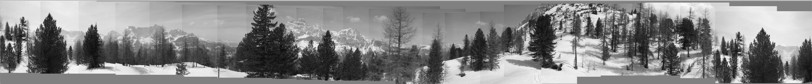





Figure 1 - some results

After trying with and without cylindricalProjection, I noticed how the projection is essential to make the images correctly overlap with each other, without it, the simple translations cannot perfectly stitch together the images and a warp is needed instead.

I also tried to equalize the histogram of the single images before stitching them, but I noticed a slightly better result without the equalization, the only dataset which gives better result using equalization is the “dataset_lab_19_automatic” in which the images differ a lot in brightness between them.

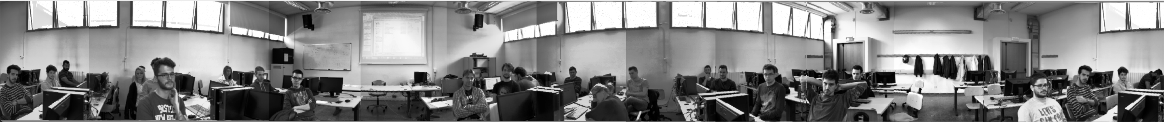

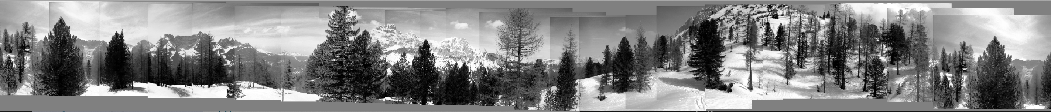



Figure 2 - result with equalization